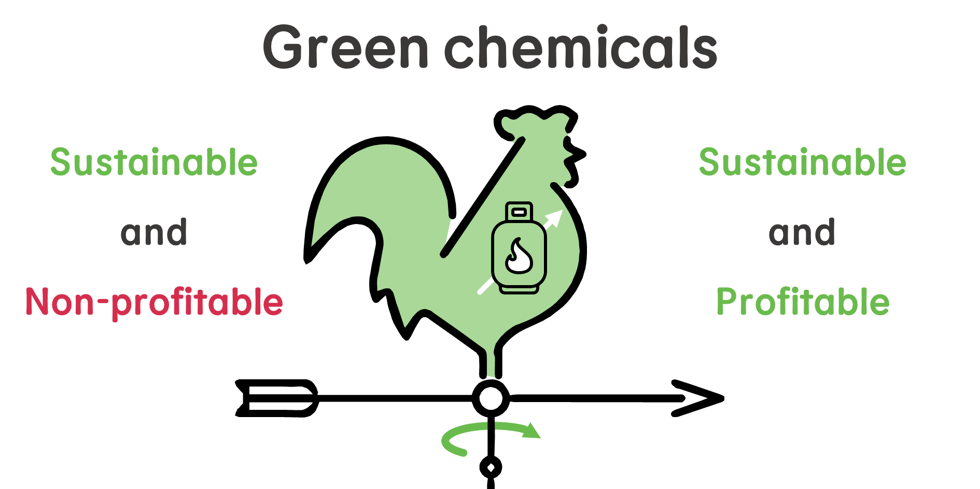
Europe's energy crisis has made green routes for ammonia and methanol synthesis economically competitive. This presents an opportunity for Europe to lead the grand transition towards a sustainable chemical industry.

